**Deep displacement real-time monitoring system**

**Table of Contents**

**I. Background ，，，，，，，，，，，，，，，，，，，，，，，，，，3**

**II. Products 。。。。。。。。。。。。。。。。。。。。。。。。。。。。 3**

**II****I. Application Areas 。。。。。。。。。。。。。。。。。。。。。。。7**

**VI. Program Introduction 。。。。。。。。。。。。。。。。。。。。。 7**

**V. Should Case 。。。。。。。。。。。。。。。。。。。。。。。。。 9**

**I. Background**

Every year, the disasters caused by slope collapse cause serious losses to the country and people. Real-time monitoring of slopes is an effective means of preventing accidents and minimizing hazards.

Commonly used methods, such as GNSS, INsar, radar method, slope survey and hydrology, rainfall, and so on. The most intuitive methods for slope monitoring are surface monitoring and deep displacement monitoring.

Deep displacement monitoring is the most valuable. Existing technologies on the market are limited in their accuracy and monitoring parameters due to factors such as the monitoring principle.

**II. Products**

Multi-dimensional micro-magnetic high-precision displacement monitoring system

The multi-dimensional micro-magnetic high-precision sensors independently developed by our company can realize fully automatic real-time monitoring of displacement changes inside the slope, which fundamentally solves the existing pain points. The system consists of three major parts: an array-type high-precision micro-magnetic flexible inclinometer composed of high-precision sensors, a data acquisition unit and a transmission unit, and a data analysis platform. It has obtained a number of inventions, new patents and soft writings, and has completely independent intellectual property rights.

1. Sensors

A single sensor to the earth's intrinsic vector field to the north as a reference can be synchronized to measure the displacement, inclination and direction of the displacement direction of the building, geotechnical body has more value for the application of the direction of the displacement of the building, the application of a wider range of applications, such as earth and rock dams, high slopes, flexible structures, floating platforms and other foundations on the water.

|  |  |
| --- | --- |
| Parameter | Indicator |
| Displacement accuracy | <±2mm/100m |
| Angular sensitivity | 0.001° |
| Orientation accuracy | ±0.5° NE |
| 3D measuring range | 360° (spherical space) |
| Maximum allowable length | 220m (single section 1m) can be customized |
| Water Pressure Resistance | ≥2MPa |
| Working Temperature | -40℃~+70℃ |
| Temperature monitoring | ±0.5°C |
| Water level (optional) | 0.01m |
| Parameter | <0.03w/only |
| Displacement accuracy | 12V DC / 220V AC / Solar |
| Angular sensitivity | Φ30×1000 (support customization) |
| Orientation accuracy | Approx. 1.1kg/only |

2. Principle

Innovation point:

Real-time monitoring of displacement, inclination and direction of the monitoring point by using earth micro-magnetic passive sensing technology.

Monitoring principle:

This equipment is based on high sensitivity micro-magnetic sensors to monitor the weak geomagnetic changes in the X,Y,Z axes at different locations, and then analyze the spatial attitude of the equipment by integrating the Gaussian geomagnetic field model, space vector calculation, etc., so as to accurately measure the changes in the displacement, inclination, and direction.

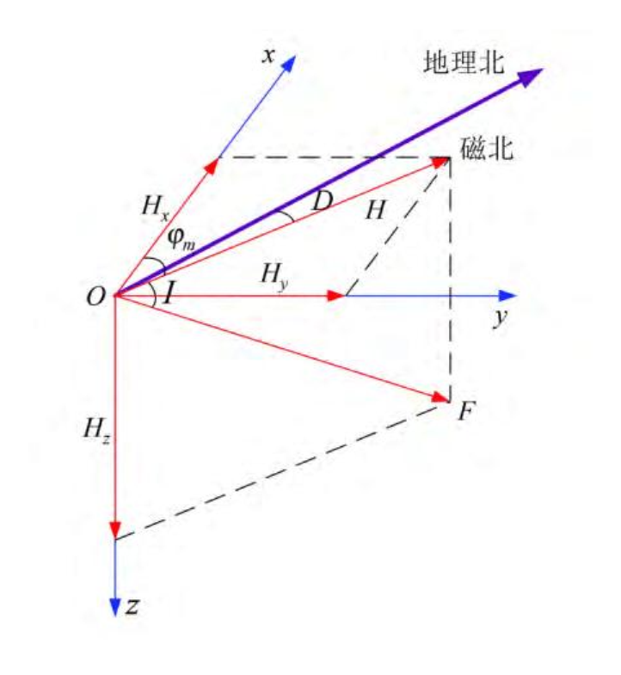

3、Monitoring platform

Self-developed, obtained software copyright

True three-dimensional real-time display of the spatial attitude of the monitoring hole, the

Display content: displacement, angle, direction, temperature, water level, etc.

Rich interface: can connect other sensors and synchronize the display, such as, rain, GNSS, video, etc.

1. 产品特点

Innovative encapsulation process: factory integrated production, lightweight design (<500~1000g/m), water pressure resistance >2Mpa, tensile strength >700KGF.

Ultra-large measurement length: CAN bus communication mode, distributed collection and storage of measurement data, centralized sending mode, overcoming the disadvantages of traditional communication methods of data packet loss, the maximum can be achieved 220 sections (sections / m) array measurement length.

Ultra-high precision guarantee: innovative algorithms and encapsulation process, to overcome the traditional encapsulation process brought about by the system torsion error, can provide more stable measurement accuracy.

Ultra-large deformation range: Innovative encapsulation process and installation process can ensure that the device and the object to be measured in a wide range of synergistic deformation, and can achieve >1000mm large deformation range measurement.

Automatic real-time telemetry: data collection at regular intervals, remote control of collection intervals, wireless transmission by DTU module.

Cloud Intelligent Management: Cloud data management system, cloud intelligent solution for deep displacement.

True three-dimensional spatial attitude: real-time true three-dimensional dynamic display of monitoring hole spatial attitude.

Multiple measurement modes: different layout and installation modes have different monitoring functions, which can meet the monitoring of foundation pit, slope, settlement, convergence, etc.

High comprehensive cost-effective: eliminating laborious on-site measurement, simple installation, easy operation without special training.

**01**

**Simple installation**

**No guide grooves**

**required**

**06**

**High Precision High Reliability**

**Fully automated, multi-parameter, 24/7**

**02**

**05**

**Wide range of application areas**

**03**

**04**

**Customized base point**

**(no need to specify an additional base point, the placement position is automatically defined as the base point)**

**Anti-interference Ultra-low power consumption**

**IV. Areas of application**

1. Depth displacement

Slopes: landslides, pits;

Inside dams: dams, tailings dams;

Flexible body deformation: curtain (underwater), underwater anchor cable.

2、Surface displacement

Settlement: bridge, roadbed, dam surface;

Tunnel: cave convergence, vault settlement;

High-rise building shear: tower, bridge abutment.

**V. Program presentation**

Displacement, mudflow, dangerous stone monitoring integration of displacement sensors, blocking network sensors, dangerous stone microseismic sensors, to achieve the deep (and surface) displacement, mudflow and dangerous stone “trinity” monitoring and early warning. Realization: deep displacement monitoring, blocking network monitoring, rolling stone monitoring.

Sensors placed across the surface of the monitoring body can monitor the settlement. The blocking net is installed with the “ground effect probe” sensor developed by our company, which can be directly hung on the net to realize the monitoring of falling rocks and mudflow.

1、Tunnel arch settlement, convergence monitoring deployment mode

Convergence: see the red line shown on the left to monitor the convergence deformation by placing it along the arc of the tunnel profile.

Settlement: Lay out along the tunnel arch to monitor the settlement of the tunnel arch, as shown by the blue line in the figure.

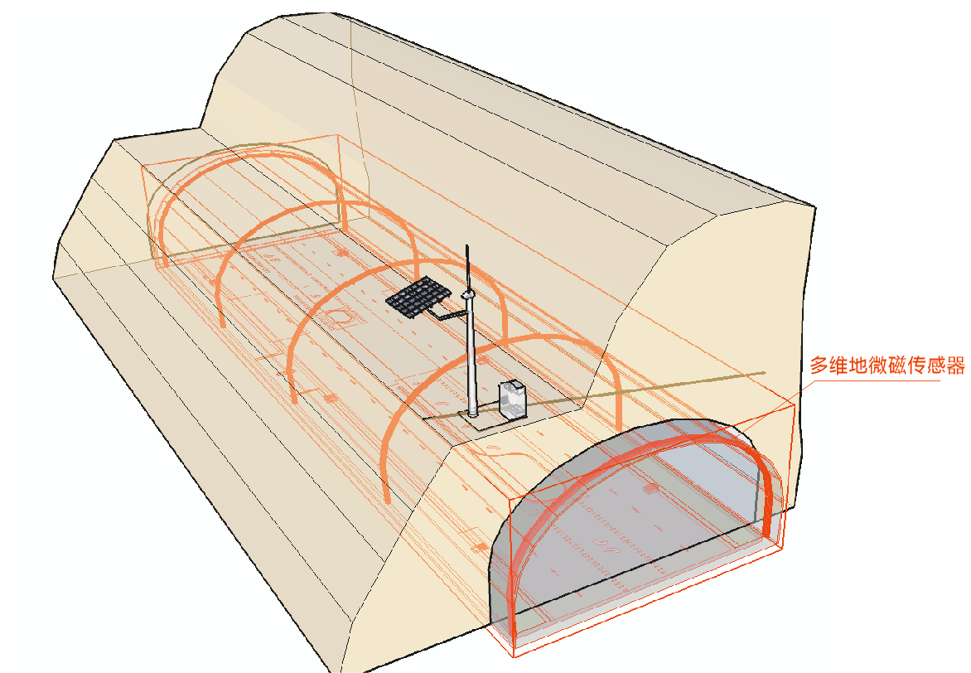

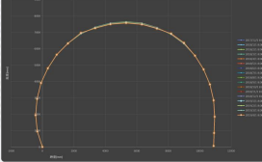

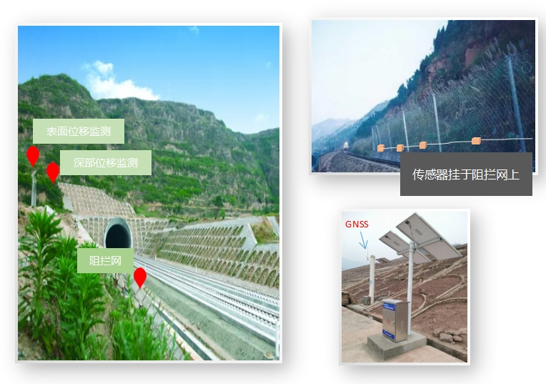

Inclined hole placement: Inclined holes were drilled above the tunnel for monitoring, see the figure on the left. According to the geological conditions and monitoring requirements, multiple holes are laid along the radial and axial direction of the tunnel.

Surface placement: digging a trench on the surface above the tunnel shallow layer (below the frozen layer) to bury in a straight line or curve (in S shape).

Slope monitoring, see figure.

Note: The distance S between the sloping hole and the highest point from the arch is determined by the design institute according to the site conditions and monitoring requirements.

The length of the sloped hole should completely cover the tunnel profile, and the other end should be extended to the immobile body.。

**VI. Should cases** Deep slip monitoring of high slopes in hydropower stations

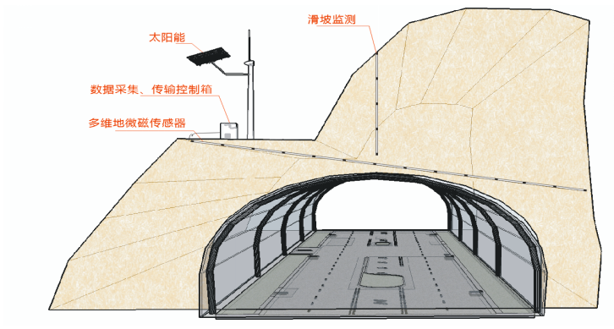

s

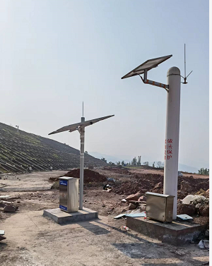 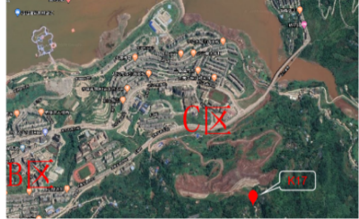

Deep Slip Monitoring of High Railway Slopes

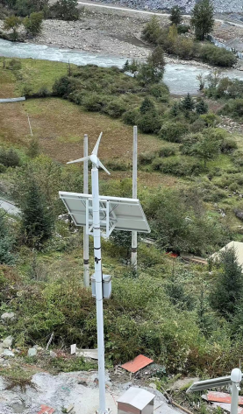 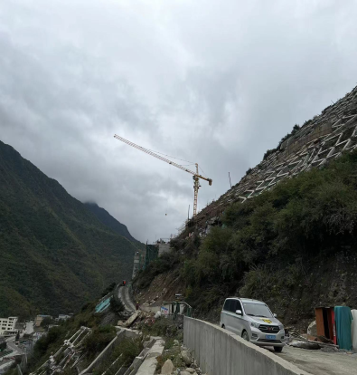

Subway, high-rise building pit monitoring

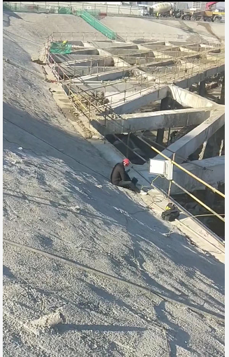

Monitoring of longitudinal cable morphology (flexible body) in the test project of water barrier wall for low temperature water management in hydropower station

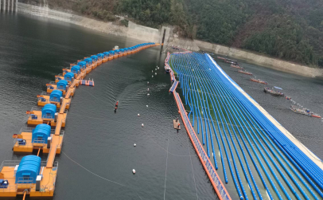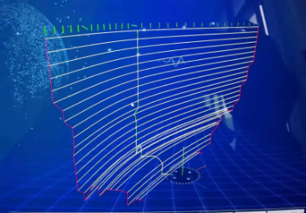

High slopes of Suijiang River in the reservoir area of the hydroelectric power station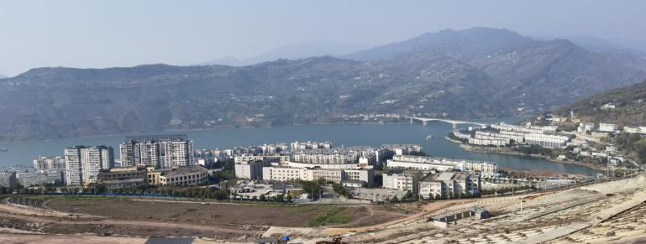

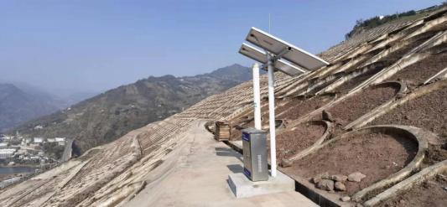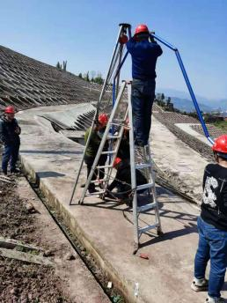

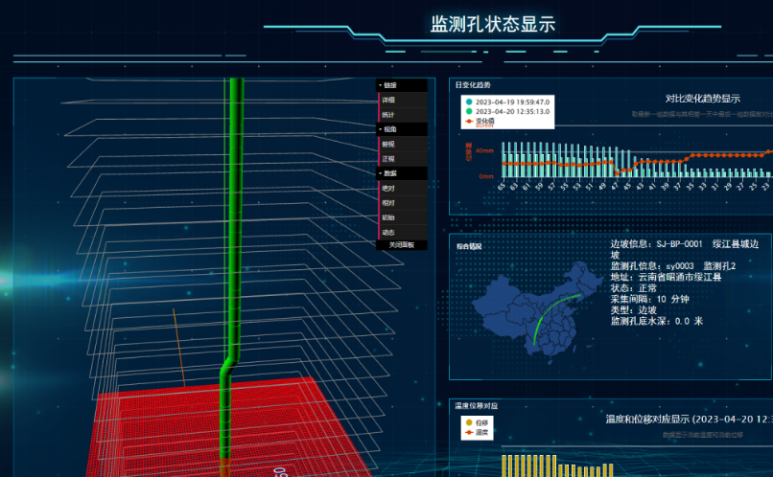

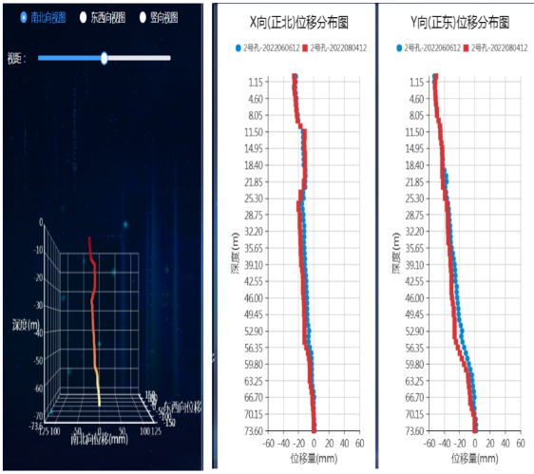

Deep displacement monitoring of high slopes in gold and copper mines

