**Ground-effect detection perimeter arming system**

**Products**

* **Passive passive acquisition technology has no impact on human health**
* **High detection accuracy and low false alarms**
* **accurate positioning**
* **Zone unit, prevention strategy customization**
* **Diversification of deployment methods**

**catalogs**

I. Overview 2

II. Principles 2

III. Application effects 2

IV. Arming structure charts 5

V. Introduction of main equipment functions and technical parameters 6

VI. Management functions 9

VII. Installation conditions 14

VIII. Installation 15

IX. Product Qualification 18

# Product Overview

"Ground Effect Probe Perimeter Arming System" is a guarding and arming product applied to the prison anti-climbing net, forming a closed or partially closed guarding unit through the front-end detector and cable, when there is a person who climbs, oversteps, destroys or carries out the prohibited behaviors of underground invasion on the anti-climbing net, the platform detects the system to send out an alarm instantly, and supervisory personnel will check the scene situation through the pre-set installation location, mobilize the camera or drone around the alarm site, and assign personnel to carry out on-site investigation. Set the installation position, mobilize the alarm site around the camera or drone to view the scene, assigned personnel to carry out on-site investigation. The system can be installed on the stone column or ground surface under the anti-climbing net, or buried in the ground according to the need.

# principle

The core technology of this product adopts microwave array intelligent detection technology, front-end detectors installed inside the microwave signal network, used to collect microwave signal changes, with waterproof cables to form the detection of protected areas, the formation of microwave detection induction field. When there are people climbing, destroying, over the protection network caused by vibration, resulting in microwave signal changes, was captured by the detector through the communication cable transmitted to the communication module for data analysis and computing, if it reaches the pre-set alarm value after the alarm platform to send out alarm signals immediately.

# Application effects

* **No effect on the health of the exposed population when the equipment is in operation**

"Ground Effect Probe Perimeter Arming System" adopts passive passive collection technology, installed in the prison under the anti-climbing net approach to the anti-climbing net to prevent the alarm, the normal operating state does not actively emit any detection wavelengths, low power consumption per unit of time, for the anti-climbing net around the activities and operations of the crowd without any health impact, to ensure that the frequency of equipment, can be used 24 hours a day continuous reading. It can be used 24 hours a day.

* **The alarm rate of the "Ground Effect Detection" system is ≥95%.**

This product has been certified by the testing center of the Ministry of Public Security, and the working alarm rate is ≥95%, which can ensure higher working efficiency.

* **The product has a low false alarm rate and reduces the number of supervisory police calls by personnel.**

Front-end detectors can be buried in the ground laying options, the shell is made of explosion-proof cast aluminum, in line with IP68 prevention standards, rain, snow, wind, sand and other weather can still work normally; due to the use of intelligent detection technology, the system can carry out its own alarm analysis, when the human body unintentionally touches the anti-climbing network or walking in the detection area, jumping up and down or small animals will not cause false alarms, reducing the number of supervisors out of the police.

* **The laying program can be selected according to the user's needs, and can meet the adjacent detector spacing of any distance between 3 meters and 16 meters.**

Users can choose the laying plan according to the cost, the maximum laying distance between two adjacent detectors is 16 meters, and the optimal laying distance is 12 meters. Without considering the cost, the laying distance can be reduced to 3 meters, and a variety of detection accuracy can be selected.

* **Users can define their own defense zone unit, the product reserved communication interface, with a variety of monitoring systems.**

The system reserves the communication interface, can be connected to the user command center through the server, with the original monitoring system to achieve the effect of multiple monitoring. Users can set up the defense zone unit according to different alarm requirements, with independent detectors or multiple detectors to form a defense zone unit to prevent alarms. The alarm units work independently and do not affect each other.

* **Alarm parameter customization, log storage, can meet the needs of a variety of prevention strategies**

Differing from the function of some existing arming equipment to set alarm value uniformly, this product can set parameters independently for each detector, so as to achieve the customization of alarm parameters for single defense zone. Alarm information is automatically stored in the database, which can be queried according to the time, defense zone unit and other conditions to meet the needs of a variety of prevention strategies.

* **Not restricted by the geological conditions of the laying place, all underground intrusion behaviors in the detection area are alarmed.**

The installation environment of the product is not restricted by geological conditions, and can be used normally under the conditions of soil, asphalt, cement, etc. It can prevent underground intrusion in the detection area.

* **Diversification of arming methods to meet the user's arming needs.**

The product can be buried in the ground, placed in the water, grass, made of camouflage and other ways to arm, to meet a variety of users arming needs.

# Arming structure diagram

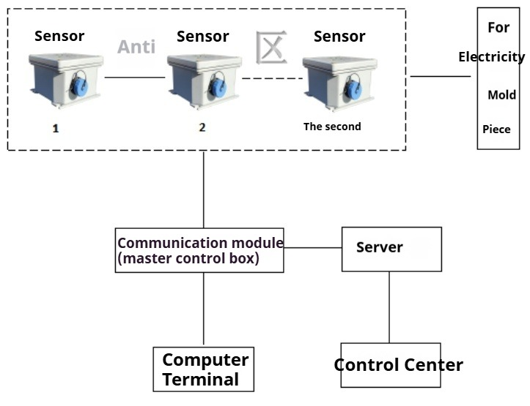

# V. Introduction of main equipment functions and technical parameters

1. **Ground Effect Detection Sensors**

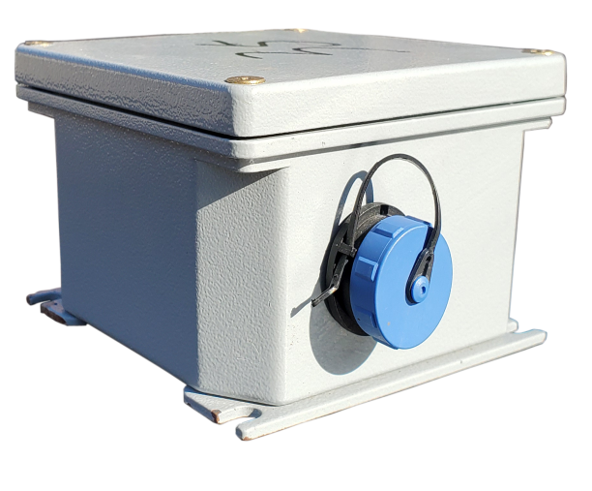Ground effect detection sensor adopts passive passive detection mode, does not send out any electromagnetic wave and harassment wave, can realize xyz three axis combined amount of omni-directional detection, the hardware adopts a high degree of integration and ultra-low power consumption design and anti-interference and protection technology. Used for microwave signal acquisition, internal microwave signal network, can detect microwave signal changes, detection of the minimum accuracy of 1nt, xyz three-axis all-around detector minimum detection accuracy can reach 4nt (in the outside world under the premise of non-interference), and the signal data through the cable transmission to the communication module.

**Ground Effect Detection Sensor Technical Parameters:**

|  |  |  |
| --- | --- | --- |
| 1 | norm | 100mm L*100mm W*62mm H |
| 2 | operating voltage | DC48V |
| 3 | Operating Current | 3mA |
| 4 | sounding position | xyz triaxial |
| 5 | Minimum detection accuracy for single-axis detection | 1nt |
| 6 | Minimum detection accuracy in xyz-axis | 4nt |
| 7 | Housing Material | Explosion-proof cast aluminum |
| 8 | Detector communication method | CAN bus |
| 9 | Detector and PC communication method | Ethernet |
| 10 | Shell protection grade | IP68 |
| 11 | Layout | Buried in the ground, placed in water, bushes |
| 12 | working environment | Rain, snow and fog |
| 13 | Detection Alarm Rate | ≥95% |
| 14 | Designed for impact resistance | IK08 |
| 15 | Housing Color | light gray |
| 16 | weights | Approx. 400g |

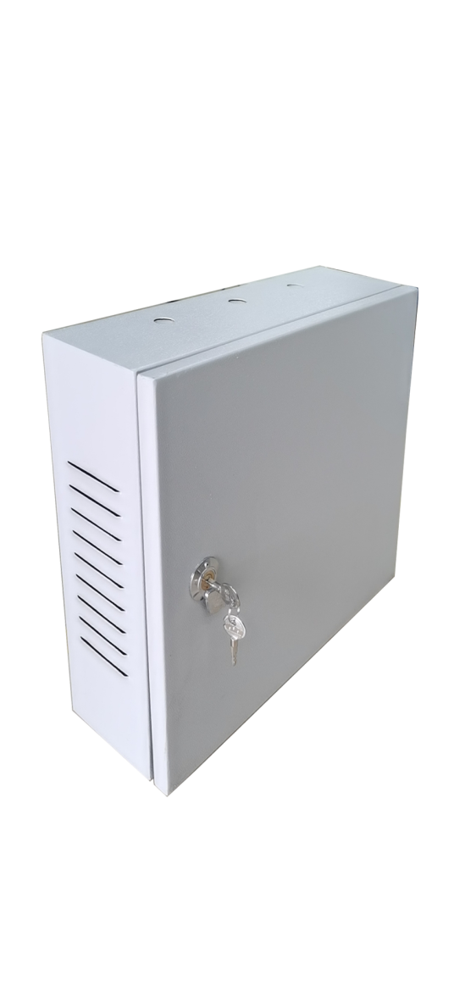

1. **Communication module (master control box)**

The communication module is installed in the middle position of the whole arming area, which is composed of data fusion processing unit, communication management processing, and alarm output unit, and is responsible for calculating and analyzing the microwave signal data coming from the detecting sensors, which can link up the sound and light alarms, and at the same time uploading the monitoring data information to the alarm platform software.

**Technical parameters of the communication module (master control box):**

|  |  |  |
| --- | --- | --- |
| 1 | norm | L430mm×W360mm×H120mm |
| 2 | Input Voltage | DC220V |
| 3 | operating voltage | DC12V |
| 4 | Operating Current | Approx. 2A |
| 5 | Can communication module interface | 2-way |
| 6 | material (that sth is made of) | Waterproof paint-coated metal box |
| 7 | Appearance Color | light gray |
| 8 | Power connector | 1 |
| 9 | network interface | 1 |
| 10 | communications module | Integrated can bus communication module and Ethernet dual network interface communication module |
| 11 | Number of detectors supported | 250 |

1. **Power supply module**

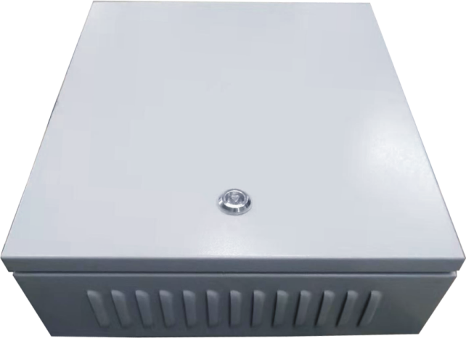The power supply box adopts waterproof paint spraying metal box, with good ventilation and heat dissipation design, power supply range of 300 meters, to each group of detection sensors for daily 220V power supply, and can be in the line longer in the need to boost power supply to ensure that the detection sensors work properly. According to the user's needs with the battery, a single battery power supply distance ≤ 300 meters.

**Technical parameters of the power supply module:**

|  |  |  |
| --- | --- | --- |
| 1 | norm | L430mm×W360mm×H120mm |
| 2 | Input Voltage | DC220V |
| 3 | operating voltage | DC48V |
| 4 | material (that sth is made of) | Waterproof paint-coated metal box |
| 5 | Appearance Color | light gray |
| 6 | weights | Approx. 8kg |

1. 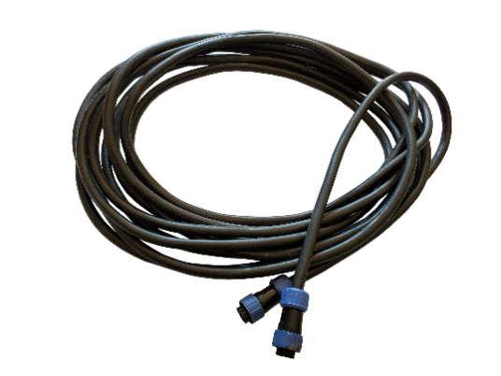**communication cable**

For power supply and data transfer between devices.

**Technical parameters of communication cables:**

|  |  |  |
| --- | --- | --- |
| 1 | Sheath Specification | UV resistant, waterproof, special for outdoor cables |
| 2 | Interface Specifications | Outdoor waterproof aviation plug-in |
| 3 | Cable Features | Alarm, communication, power supply |
| 4 | material (that sth is made of) | polyethylene |

# VI. Management functions

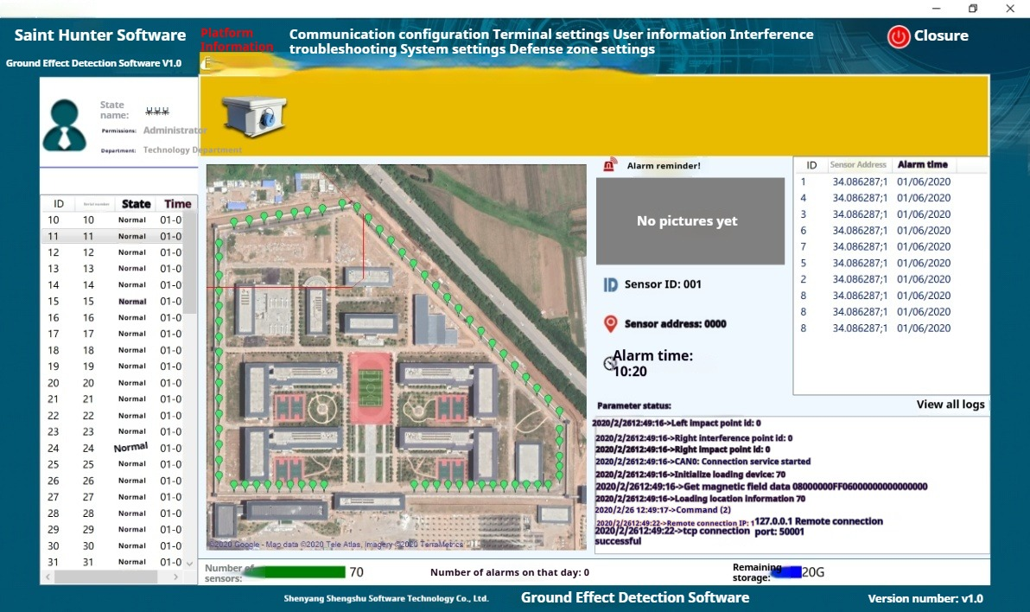

**1、Alarm defense zone unit customization function**

Users can customize different zone units according to their needs, and can set a single detector as an alarm zone unit or multiple detectors as an alarm zone unit.

**2、Customize the security check strategy**

The system can control and adjust the setting of detection standard value of individual sensors, name (in the form of region or location), function on and off. When the whole set of equipment installation is completed, each sensor needs to be individually parameterized, due to the installation of different locations of the intrinsic detection value is different, the alarm standard is also different, so that the whole set of equipment alarm is more accurate. The whole system can be unified to set the sensitivity, alarm function on and off, can be customized for a single anti-zone unit working time customization.



Complete system regulation diagram

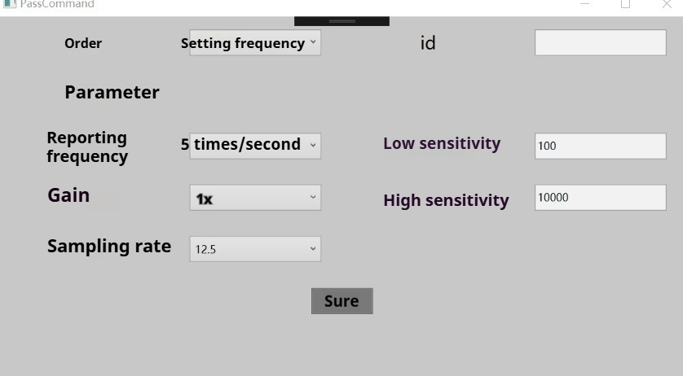

Individual Detector Adjustment Chart

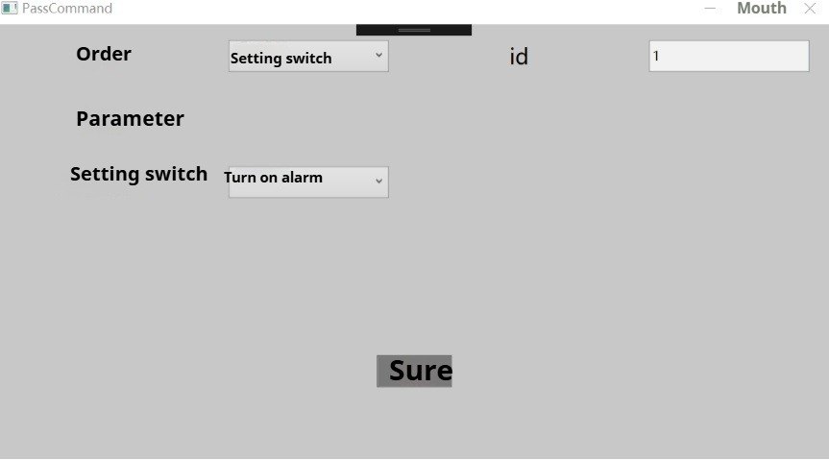

Individual detector function on, off diagram

**3、Authority management function**

The system can be used according to the user's needs for personnel authority settings, can determine the user name, authority, belonging to the department, each account can only perform their own authority within the operation, to achieve a single person, single-proof area targeted monitoring, monitoring the region is clear, independent, do not interfere with each other, with the confidentiality of confidential information.

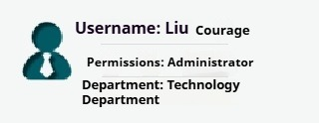

1. **Arming panoramic visual monitoring function**

The system can present the arming locations of the whole set of equipment in the form of a map, so that the supervisors can intuitively view the arming range as a whole. If an alarm occurs, the corresponding arming point will be displayed in red; if the sensor fails, the corresponding arming point will be displayed in orange; when working normally in standby, the arming point will be displayed in green.

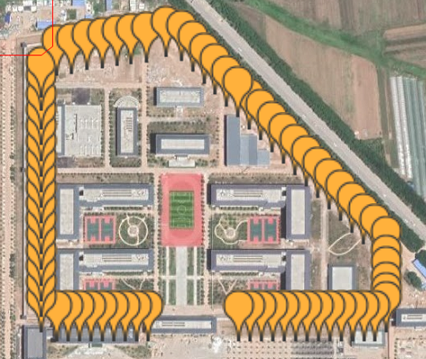

**6, and monitoring cameras, drones, alarm sirens and other linkage functions**

This system has good compatibility and upgrading space, can be linked with the prison original has drones, cameras, alarm sirens and other equipment to form a joint arming, and can be cameras, drones captured by the first transmission of the screen to the supervision platform. The picture and information transmission process are in the form of signal to prevent malicious invasion and theft.

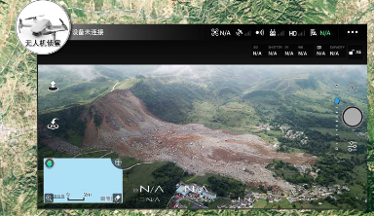

The system with universal interface and compatible with a variety of communication protocols, both through the network cable connected to the remote monitoring computer end of the independent work, can also be embedded in the prison system's integrated command platform.

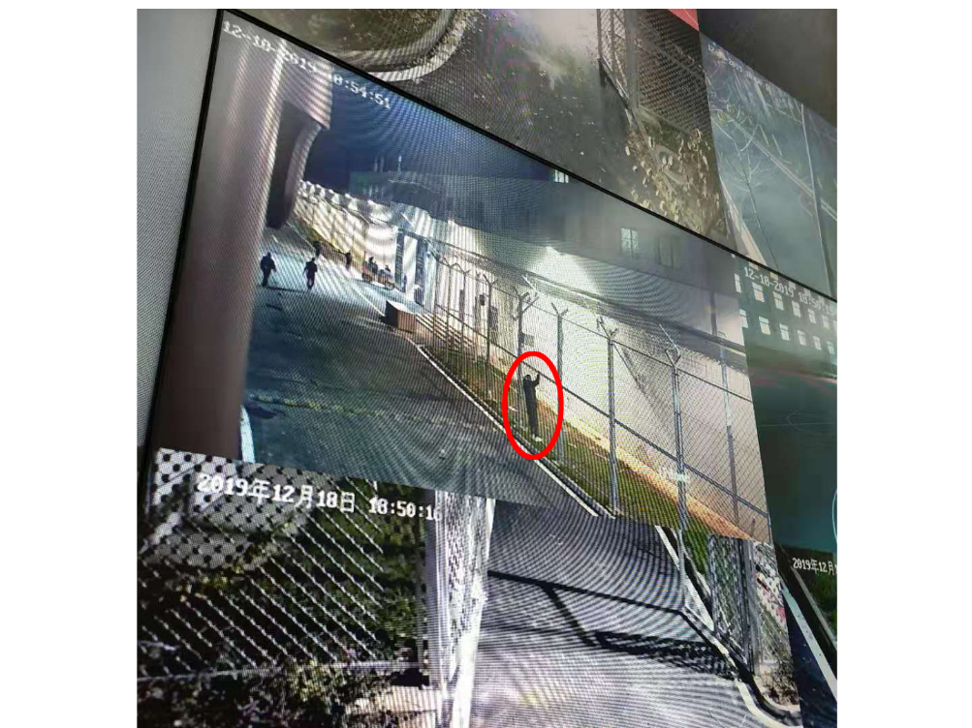

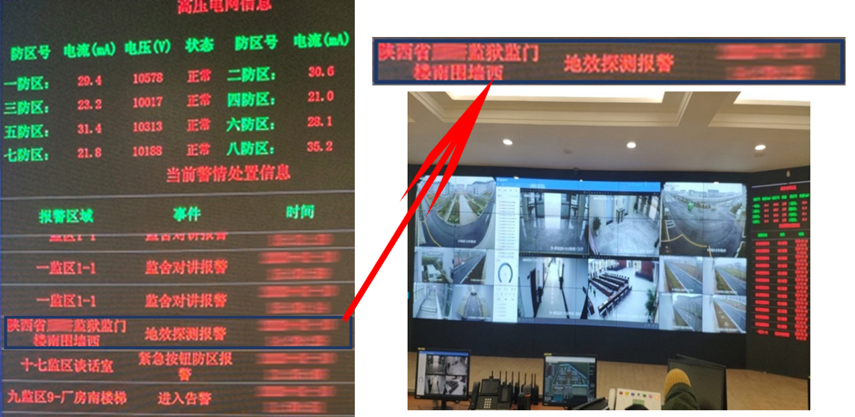

**7, alarm sensor positioning processing function**

When an alarm occurs, the system views information such as the name of the alarm sensor, its location, and the time when the alarm occurred, and can view the map location of the most recent alarm situation.

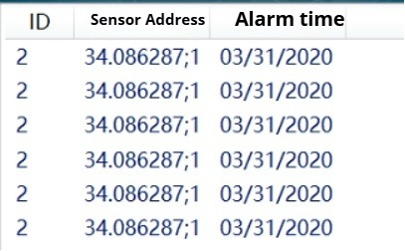

### 8, log storage query function

The system automatically stores each alarm information in the form of a log, which can be queried by the management personnel according to the information of sensor name, installation location, alarm time and alarm processing.

17333098048403

### 9、Working status display function

The system can view the whole set of equipment working status information, the number of sensors, the number of alarms, storage space situation.

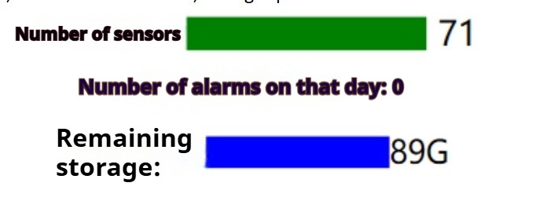

### 10, alarm response speed

After monitoring by the monitoring center of the Ministry of Public Security, the alarm response time from the relay transmission module to the warning control terminal of this system is ≤1S.

# VII. Installation conditions

* Users are required to provide a computer or server to install the client.
* The recommended configuration for the computer or server is, 8G RAM, 500G hard disk, 8 cores CPU.
* The computer or server must be using WIN7 SERVER 2008 or higher.
* Users are required to provide more than two sets of available network interfaces.
* In order to meet the use of the effect of ground effect detector needs to be installed in the anti-climbing net below 10-15CM.
* A 220V AC power supply for the power box is required every 300 meters.
* A network interface to a computer or server should be provided for the master control box in the middle of the entire defense zone.
* Where the installation of power supply boxes or master control box anti-climbing mesh columns, are required to anti-climbing mesh columns above and below the opening of each 1-2 20mm threading holes.
* Note: If the site arming conditions do not meet the above requirements, you can customize reasonable arming conditions after communicating with Shenyang Sheng Hunting Marketing Department.

# VIII. Installation

(1) This set of equipment can be installed according to the user's needs, can be installed in the anti-climbing net below the stone column or the surface, can also be buried underground to achieve the effect of covert arming. If you choose to bury underground, the following steps are required:

Digging base trench: the trenching personnel use shovels, hoes along the anti-climbing net below digging a 150mm deep and 100mm wide base trench, the length of the base trench and anti-climbing net consistent. (Note: anti-climbing net for the closed fence area, in order to ensure the integrity of the connection of the detection device, the visual range of the guardhouse also need to dig slots.)

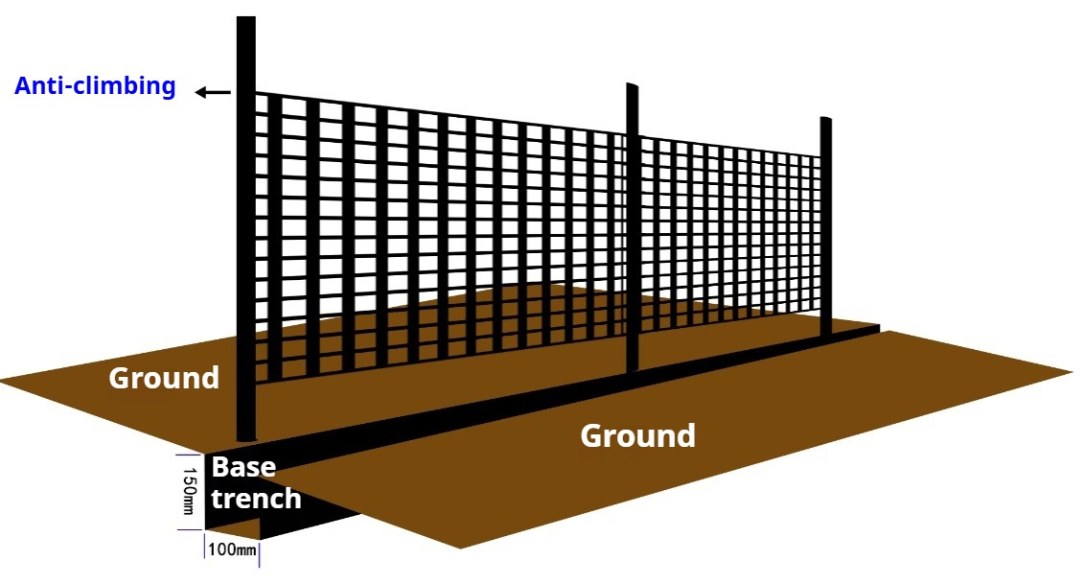

(2) Ground effect detection sensor placement:

Place the "Ground Effect Detection Sensor" under the single anti-climbing net, and try to place it in the middle position, and the detection distance of single detector is up to 12 meters as the best, more than 16 meters will affect the detection accuracy.

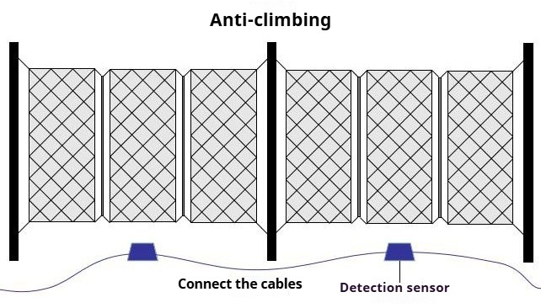

(3) Cable selection:

The cable is a five-core 0.5²mmx5 and above waterproof communication cable.

(4) Laying cables: In order to prevent too much material and increase the chance of safety hazards, the laying of cables is prioritized by the shortest route.

Before laying the cable should be insulated test, wire, cable line and line to ground between the insulation resistance value must be greater than 0.5MΩ, test qualified before laying.

Placement of cables should be neatly arranged, not twisted, minimize crossover, cross the thick line at the bottom, thin line on the top.

There shall be no joints for cables in the pipe, and the joints must be connected at the box (case).

The ends of the cables laid must be well marked.

Link the signal wire, lock nut to ensure secure.

(5) Installation of power boxes (power supply modules)

Use hand drill and other tools to install the power box evenly and reasonably on the column of the anti-climbing net, three meters from the ground. (Note: The installation position of the power box is evenly arranged around the anti-climbing net.)

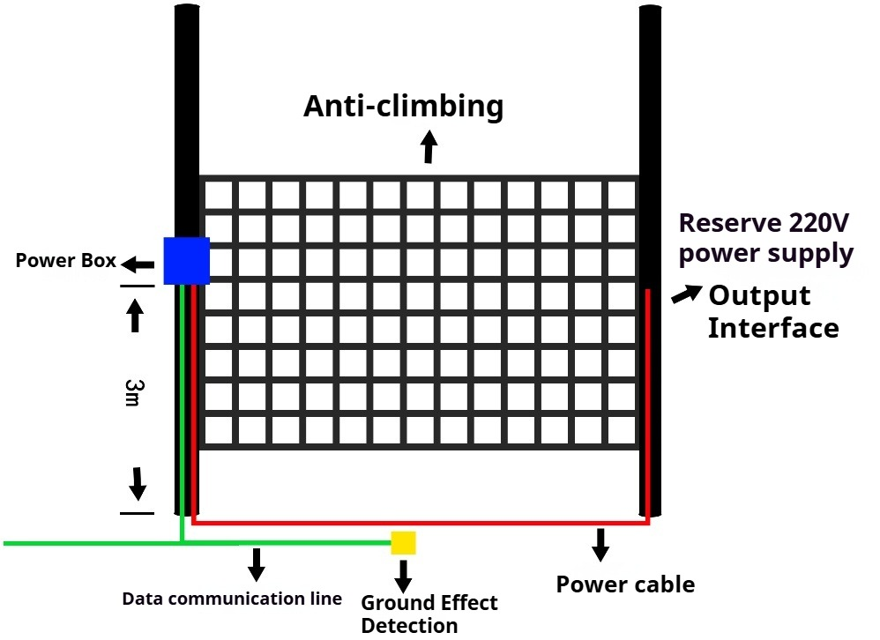

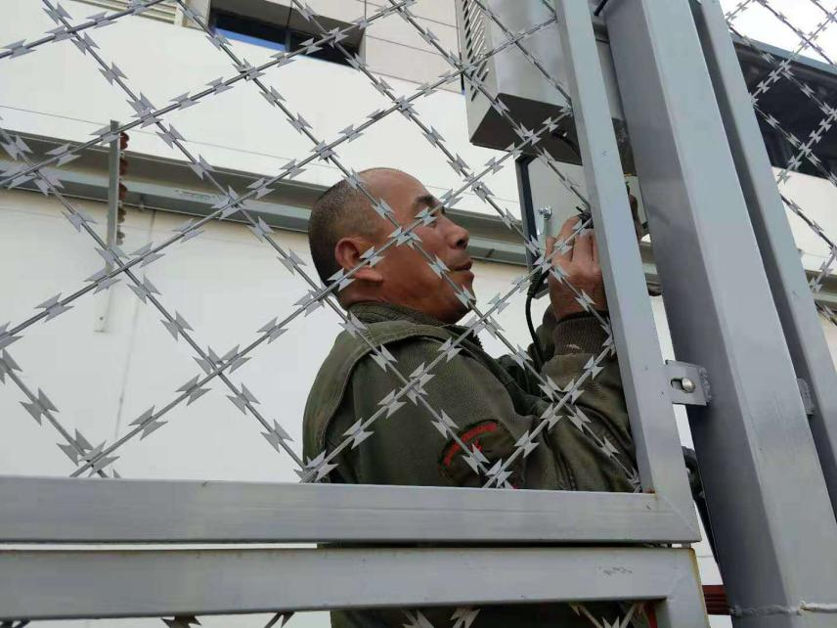

(6) Turn on the power supply and network cable

The power supply for the whole ground effect detection device needs to be provided by the user with a 220V power output port, and an output terminal is required every 300 meters. At least one network port should be provided by the user, which can be connected to the server room or server.

(7) Overall commissioning

After the ground effect detector arrangement is completed, the technician will install the "alarm platform" on the server (the server needs windows system) or PC (the PC needs windows 7 or 10 system sp1 or above) designated by the user. The installation of "Alarm Platform" is not affected by the order of the ground effect detectors, and can be installed in the first step if required.

After the installation of the alarm platform is completed, connect all the power, open the monitoring system, according to the use of demand to adjust each ground effect detector sensitivity, to achieve the optimal effect.

(8) Functional Testing

After the debugging is completed, each detection point is tested repeatedly for many times, and the detection accuracy rate reaches the use requirements. Test the alarm platform alarm, positioning, parameter adjustment and other functions are normal.

(9) Technical training

Professional technicians will provide technical training to the user's supervisory staff in accordance with the user manual, so that they can skillfully use the alarm platform and troubleshoot simple problems.

# IX. Product qualification

* Ministry of Public Security test report
* CMA test report
* Software Product Test Report

